

Heat Exchangers and Heat Transfer (2025-2026)
Course code: B51GL
Assignment 1
Design of Plate and Frame Heat Exchanger

Name: Gauravsingh Rajput

Introduction
In this report we will be focusing on the design of heat exchanger using HTRI (Heat Transfer Research Inc.) software, the exchanger is Plate and Frame heat exchanger.
Problem Statement:
To design a suitable plate and gasket heat exchanger that can be used for heat recovery and maximizes the outlet temperature of the low wines. The Low Wines can be heated to the desired temperature using supplementary heating from the outlet heat exchanger temperature, if required.
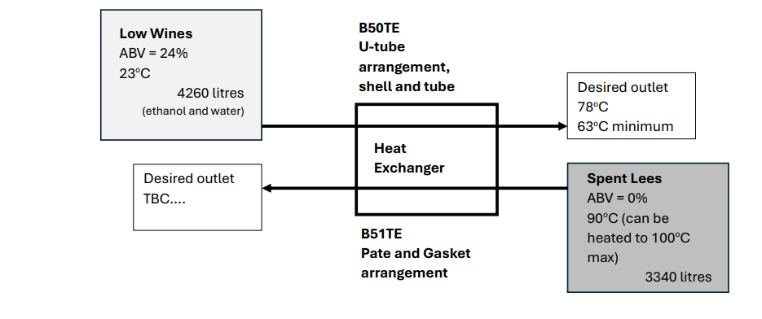

My Approach:
So to design a Plate and Frame Heat exchanger, the line of action that I will go ahead with is by keeping business and industrial profit in mind. Whisky distillation is a cost sensitive industry and has a pretty competitive market due to which company focus on profit margin by keeping quality, energy efficiency, and maintenance in mind.
So the parameters for heat exchanger used are, deliberate tradeoff that keeps operational cost saving and initial capital expenditure in priority. I will be using USD as a standard currency to calculate the price of heat exchanger along with other criteria.
I will use HTRI software, to design heat exchanger in which I will be considering three options based on parameters such as overdesign, flow-rate, port velocities, pressure drop (less than 50kPa), single pass countercurrent flow and select best out of them. I am considering the case of zero fouling but design will be in such a way that it can resist fouling.
And reason for choosing low heat duty was because time for the process was not mentioned so to make heat exchanger simple, I went ahead with low heat duty and simulated three different cases based on overdesign.
Possible Design:
Case 1: Design emphasizing on durability and cost saving
Case 2: Optimized design of case 1 focusing on efficiency and increasing overdesign
Case 3: High Overdesign for flexibility

Plate and Gasket Heat Exchanger
Heat exchanger is a device used to transfer thermal energy from one fluid to another that is from hot to cold and fluid never meet or mix.

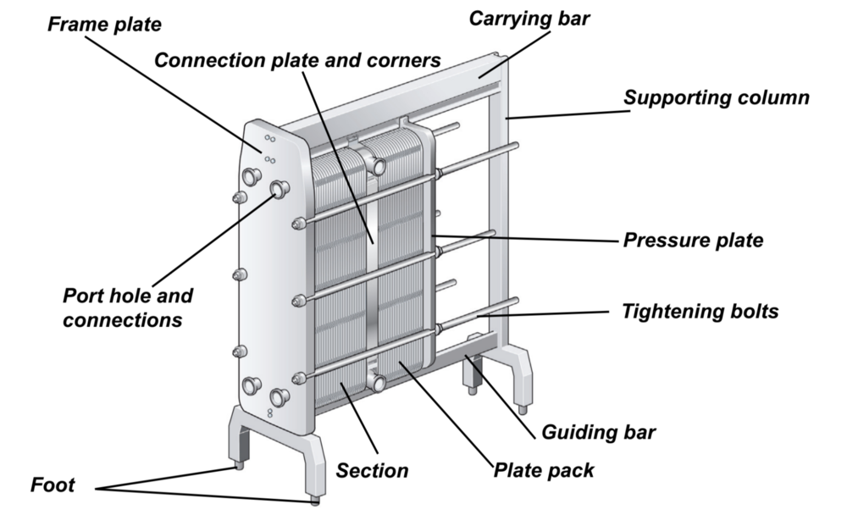
Figure 1 Plate and Frame Heat Exchanger [2]
Unlike traditional shell and tube designs, plate and gasket heat exchanger consist of multiple thin metal plates sealed together with gaskets, creating alternate channel for hot and cold fluids to flow in alternating patterns.
To maximize the heat flow, plates used are often grooved to increase the surface area. Operation of plate and gasket heat exchanger relies on counter current and co current flow arrangement that is the flow of heat and efficiency can be changed depending on the process parameters. [1]

Cases Simulated in HTRI

Three possible designs and justification of the final selection

Case 1 -- Design Emphasizing on Durability and Cost saving (Option selected for Design)

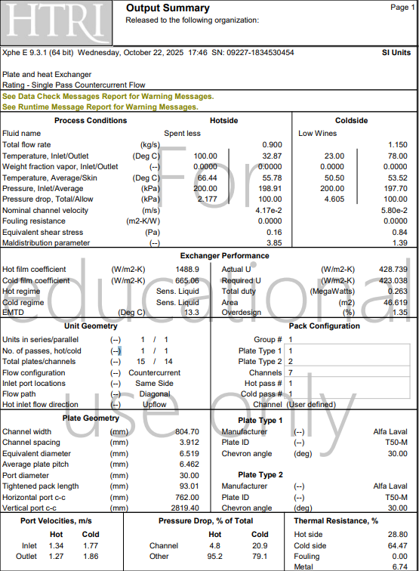

Case 2 -- Optimized design of case 1 focusing on efficiency and increasing overdesign
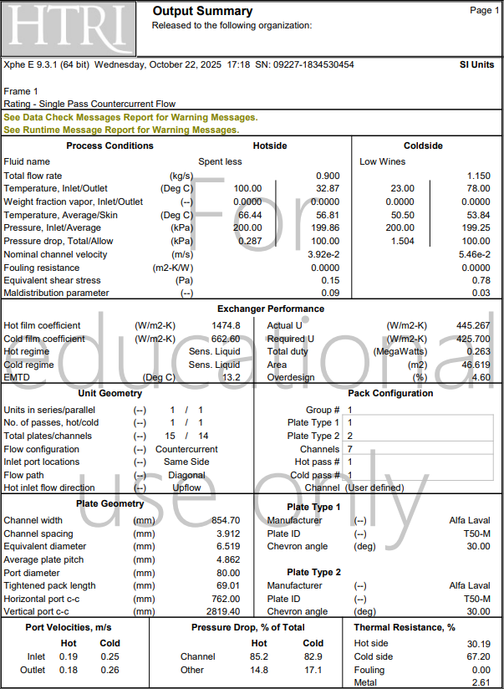

Case 3 -- High Overdesign for flexibility
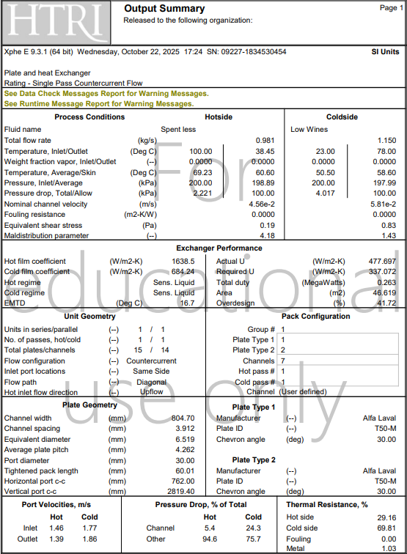

Case 1 (Input Parameters)
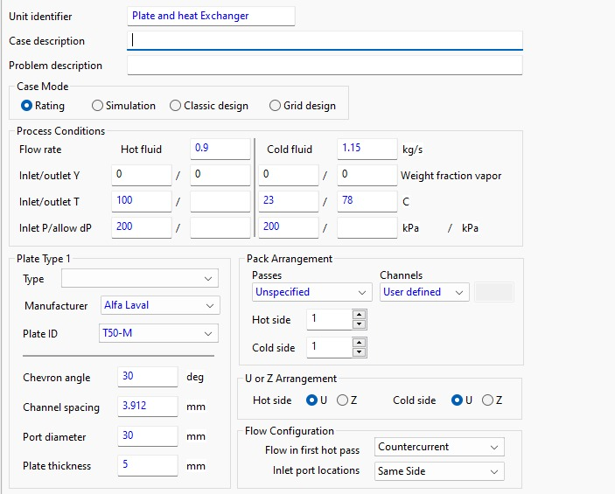

Reason for Selecting Case 1
Now when I compared case 1 with rest of the cases, major driving factor for selecting case 1 over 2 and 3 was keeping long term stability, low initial investment, low maintenance and labor cost in mind.
Case 1 meets the required capability for heating Low wines to desired temperature, along with eliminating supplementary heating.
Another reason for choosing case 1 over high heat duty exchanger (1000 – 4000 W/m² K) was to avoid unnecessary cost, complexity of higher overdesign.
Merits over other two design case:
- High Thermal Efficiency: This design achieves low wines outlet temperature of 78 °C, using heat from Spent less that is hot side without external heat source.
- Compact Design: Requires less space than alternatives, fitting in small spaces
- Easy Maintenance: When above heat exchanger with heat duty of 400-600 W/m² K is compared with heat duty of 1000 – 4000 W/m² K, has easy maintenance
- Cost effectiveness and Lower Initial Investment: Maximize heat recovery which eliminates the use of supplementary heating
- Scalability: Plates can be removed or added accordingly if production value changes.
- Lower maintenance cost: Fewer plates and compact design reduces cleaning effort, as alcohol at lower flow rate tend to foul more.
- Faster Return of investment (ROI): With lower initial investment, payback period is lower which aligns with growing craft whisky market.
- Sustainability Advantage: By minimizing overdesign, we can reduce the resource waste which directly affects CO2 emissions, and also aligns with the Carbon emissions goals.
- Lower pumping cost: Flow in this heat exchanger is laminar so pumping cost is less when compared to turbulent cases, small production industries can save in pumping cost.

2-D design of Plate Heat exchanger

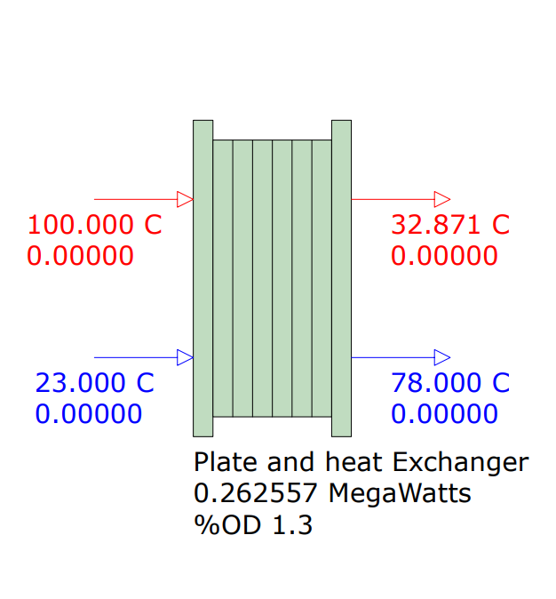

Manual heat balance (duty) to confirm HTRI calculation
Heat Balance (Low Wine Cold side)
Q_{c}= m C_{p} delT = 1.15 * 4186 *(78-23) = 264.764 kW
Heat Balance (Spent less Hot side)
Q_{h} = m C_{p} delT = 0.9 * 4186 * (100-32.87) = 252.905 kW

Spent Less (to manually estimate heat transfer coefficient)
Here, we will be using Nusselt number analysis: (using value of mu at 100 C , k = 0.6768 W/m K )
Nu = 1.86 Re^{0.33} Pr^{0.14}
Reynolds number = (rho v D) / mu
= (958.35*0.0417*0.006519)/ 0.0002814
= 925.799 (This shows that the flow is laminar and in transition phase)
Prandtl number = (mu*C_{p}) / k
= (0.0002814 * 4186)/ 0.65
= 1.74
Using Nusselt number analysis,
Nu = 1.86 Re^{0.33} Pr^{0.14}
= 1.86 * (925.799)^{0.33} * (1.74)^{0.14}
= 19.148
Now, h = (Nu * k) / D_{h}
= (17.77 * 0.65) /0.006519
= 1987.93 W / m² K
When I compare it with the HTRI hot film coefficient 1488.9 W/m², it might suggest that the temperature used in HTRI for calculation can be different for spent less as I used 100 C.
And parameters like rho, viscosity are temperature dependent values.

Confirming Surface area by manual calculation
For calculating of surface area I will be using LMTD method, I have four temperature give and they are
T_{h1} = 100 C, T_{c2} = 78 C ΔT₁ = 100 – 78 = 22 C
T_{h2}= 32.87 C, T_{c1 =} 23 C ΔT₂ = 32.87 – 23 = 9.87 C

ΔTm = (ΔT1 – ΔT2 ) / ln (ΔT1 / ΔT2) ΔTm = 15.13 C
Using heat balance, hot side Q = 0.263 MW (HTRI flowsheet)
Q = U * A * ΔTm
Before multiplying the equation with, ΔTm I will be using correction factor of 0.864
So new LMTD temperature becomes, ΔTm = 15.13 * 0.864 = 13.07 C
So, A = (263000) / (428.739 * 13.07)
A = 46.933 m²
Area calculated using LMTD method 46.933 m²
Area calculated by HTRI software 46.619 m²
Error (46.933 – 46.619 ) / 46.619 = 0.00673
Percent error = 0.673%
Note: The error is pretty low, possible reason for this error can be approximations or number of values software used for calculations.

References

[1] | Admin, "SON PLATE," [Online]. Available: https://son-heatexchanger.com/understanding-gasket-plate-heat-exchangers.html.
[2] | Admin, "M&C Heat Parts," [Online]. Available: http://www.mcplateheatexchanger.com/h-nd-13.html.

